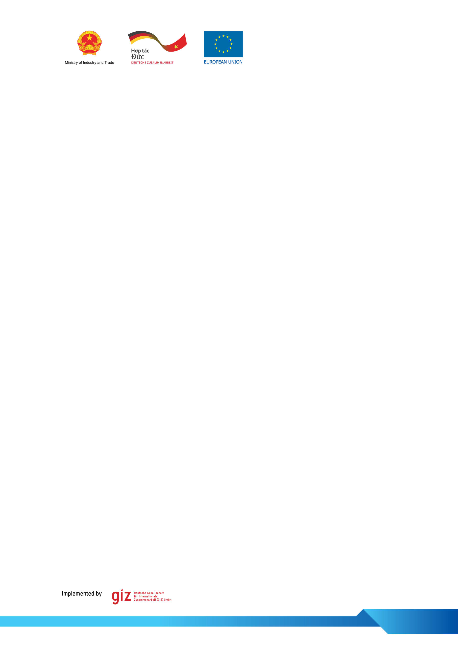

Annex 1
Template for Expression of Interest (EOI)

to the

Demand-Driven Technical Assistance Facility
(Sub-component 1B)
of the
EU-Viet Nam Energy Facility

08
Fall

- ABOUT THE APPLICANT
1.1 Project Title.
1.2 Contact Details. | Name of Organisation:
1.2 Contact Details. | Name of Contact Person:
1.2 Contact Details. | Telephone Number:
1.2 Contact Details. | Email:
1.3 Field(s) of Activities.  Please tick all applicable boxes | - Renewable Energy  - Energy Efficiency  - Access to Energy  - Energy Information
1.4 Type of Activities.  Please tick all applicable boxes | - Regulatory Framework  - Capacity Building and awareness raising  - Knowledge/Technology Transfer
1.5 Introduction  Describe the key features of the organisation and its activities, in which the Technical Assistance shall be embedded  (max 500 words) | Introduction of the Organisation (mission, vision and target groups):  Main Activities of the Organisation:  Short description of the activity in which the technical assistance shall be embedded:
- SCOPE OF THE TECHNICAL ASSISTANCE
2.1 Problem & Needs Analysis.
Describe the identified problem(s)and needs the project aims to change/ address. Specify how the project/Technical Assistance will help solve them.
(max 700 words)
2.2 Technical Assistance
Describe the Objective and Expected Results of the Technical Assistance, as well as how a sustainable impact will be ensured.
(max 600 words)
2.3 Planned Key Technical Assistance Activities to achieve the expected results.
Bullet point list of the main Technical Assistance activities requested
(max 500 words)
2.4 Beneficiaries
Describe the beneficiaries of the Project/Technical Assistance (type, number and level of involvement)
(max 500 words)
2.5 Coherence
Describe how the project/Technical Assistance is coherent with the mandate of the organisation and aligns with national policies.
(max 400 words)
2.6 Alignment with the Thematic Focus Area
Describe how the project/ Technical Assistance addresses the thematic area “Innovation, Partnerships and Networks – Knowledge Sharing and Technology Transfer to support the market development for renewable energy and energy efficiency in Viet Nam”
(max 500 words)
2.7 Partnerships
Describe strategic partnerships with other local/international entities to maximise the project’s/ Technical Assistance’s results.
Note: potential service/TA providers are not considered partners. Partners must be also beneficiaries of the TA.
(max 400 words)
- Timeline and Budget
3.1 Implementation Plan and Timeline  An implementation plan defining concrete activities and timelines of the project/ Technical Assistance has been attached to the application form. |  | YES  NO  Name of the file:
3.2 Cost Estimate  An estimate of each Technical Assistance activity proposed, and a total cost estimate has been attached to the application form. Applicants must apply UN-EU cost norms when preparing the cost estimate. |  | YES  NO  Name of the file:
- LOGISTICAL SUPPORT
4.1 Capacity to support the implementation of the requested Technical Assistance |  | “We hereby confirm that we have the capacities to support the implementation of the requested Technical Assistance (such as human resources, academic expertise and logistical support)”  YES  NO  Name, title and organization of the project manager:  Lead Applicant:  Partner 1:  Partner 2:

UN-EU Guidelines for Financing of Local Costs in Development Cooperation with Viet Nam, Version 2017 https://eeas.europa.eu/sites/eeas/files/un_eu_costnorms2017_2.pdf

